LES ANGLES
Relie
angle plat |  |  |  | 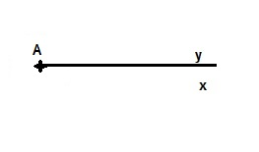
angle aigu |  |  |  | 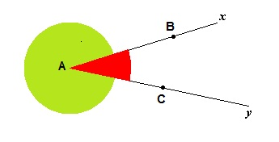
angle droit |  |  |  | 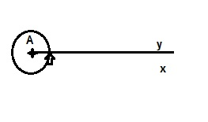
angle nul |  |  |  | 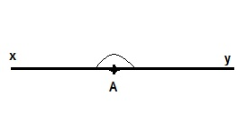
angle obtus |  |  |  | 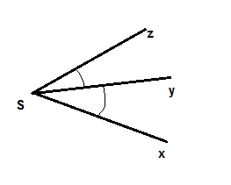
angle plein
angle rentrant |  |  |  | 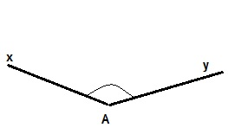
angle saillant |  |  |  | 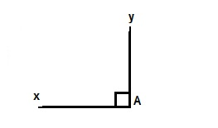
Angles adjacents |  |  |  | 